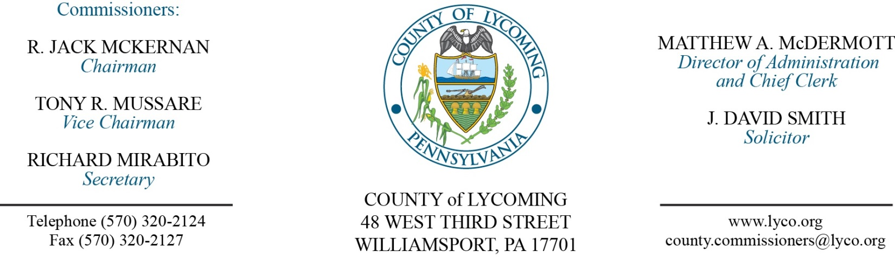
Commissioners’ Meeting Agenda
August 18, 2016

Opening Prayer

Pledge to the Flag

1.0 OPERATIONS

1.1 Convene Commissioners’ meeting.

1.2 Approve the minutes of the previous meetings.

1.3 Receive public comments (agenda items only).

2.0 ACTION ITEMS

2.1 Proclaim August, 2016 as Child Support Enforcement Awareness Month in Lycoming County. (Paulette Clementoni)

2.2 Adopt resolution 2016-16 for emergency rebuild of G-4 Conveyor Belt System and Fire Suppression Line. (Jason Yorks)

2.3 Approve quote from Bearing & Drive Solutions IV, Inc., in the amount of $35,182.80, for the completion of the G-4 Conveyor Belt System Rebuild Project. (Jason Yorks)

2.4 Approve agreement with Thermo Environmental Instruments, Inc., for the purchase of Thermo Environmental 2020 Landfill Surface Scan Meter and accessories in the total amount of $14,348. (Jason Yorks)

2.5 Approve quote from Davis-Ulmer Sprinkler Co. in the amount of $1,200. (Jason Yorks)

2.6 Approve sewer pipeline easement with Brady Township. (Jason Yorks)

2.7 Approve funding agreement with West Branch Regional Authority. (Kurt Hausammann)

2.8 Approve amendment to lease agreement with Community Traffic Safety Project. (Mya Toon)

2.9 Approve quote from RF Fager for the programmable water fixture control project in the amount of $80,648.01. (Mya Toon)

2.10 Approve constable agreement with Mark A. Phillips. (Marci Hessert)

2.11 Approve Policy 314 – Donated Day Benefit Policy of the Lycoming County Policy & Procedures Manual. (Roxanne Grieco)

2.12 Approve personnel actions: (Roxanne Grieco)
RMS - Jennifer L. Reynolds as full time replacement Clerk III/AP weighmaster – Pay grade 4 - $13.81/hour effective 8/22/16.
Pre-Release – Lisa M. Norton as part time replacement Female Resident Supervisor – Pay grade 5 - $14.00/hour effective 8/22/16, not to exceed 1,000 hours annually.
Prison – reclassification of Beverly V. Agnoni to Licensed Practical Nurse – Pay grade 6 - $18.42/hour effective 8/28/16.
Prison – reclassification of Trista N. Lukens to Licensed Practical Nurse – Pay grade 6 - $18.42/hour effective 8/28/16.
Prison – reclassification of Nicole D. Dawson to Licensed Practical Nurse – Pay grade 6 - $18.42/hour effective 8/28/16.

5.0 REPORTS/INFORMATION ITEMS

5.1 Present 20 year pin to Rob Thompson.

5.2 Comp plan survey media release. (Kurt Hausammann/Megan Lehman)

6.0 PUBLIC COMMENT:

7.0 NEXT REGULARLY SCHEDULED MEETING: Planning Session on Tuesday, August 19, 2016.

8.0 ADJOURN COMMISSIONERS’ MEETING.

